

Mark
Student: ____________________________________ 10th Grade ___ Score: ___ pts. /30 pts.

ADJECTIVES - MATCHING
I. Match the adjectives with their Spanish meaning. Be careful, there are 5 distractors. ____ /07 pts.
1. Smart 5. Boring 9. Dangerous ____ Genial ____ Peligroso
2. Easy 6. Nice 10. Expensive ____ Gracioso ____ Barato
3. Cheap 7. Great 11. Heavy ____ Costoso ____ Inteligente
4. Fast 8. Good 12. Funny ____ Pesado

COMPARATIVES - WRITE ____ /04 pts.
II. Write comparative sentences.
Example: Lucy / Megan (old) Lucy is older than Megan.

1. Chile / Brazil (small) ________________________________________________
2. Allyson / Paula (intelligent) ________________________________________________
3. English class / Math class (easy) ________________________________________________
4. Tea / coffee (good) ________________________________________________

SUPERLATIVE ADJECTIVES - CHOOSE ____ /04 pts.
III. Read the sentences and decide the correct superlative form.

1. Brazil is ____________ country in South America. (big) a) the bigest b) the biggerest c) the biggest
2. Laura is ____________ student in the class. (pretty) a) the prettiest b) the prettyest c) the most pretty
3. Today is____________ day of my life. (good) a) the better b) the best c) the goodest
4. The “Bugatti Veyron” ____________ car. (fast) a) the fasterest b) the fastest c) the most fast

SIMPLE PAST – SENTENCE ORDER ____ /09 pts.

1. Monday / went / Monica / to school / on _______________________________________________
2. yesterday / study / I / English / didn’t _______________________________________________
3. class / did / the online / start / What time? _______________________________________________?

READING COMPREHENSION / WAS, WERE – ANSWER ____ /06 pts.
V. Read about “Christopher Columbus” and answer the questions.
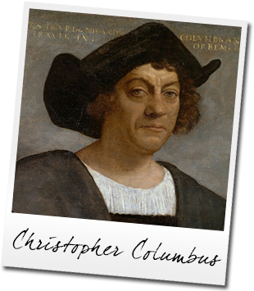
Christopher Columbus was born in 1451 in Genoa, Italy. His official birth date is unknown (between August 26 and October 31). He lived most of his life in Spain. He was a navigator and explorer who became famous for the discovery of America in 1492. On one of his expeditions, he wanted to go to the East Indies. He traveled in the ships called The Pinta, Niña and Santa Maria. When he arrived, he believed that he was in India, but he was actually on The American continent. He was in Salvador, a Caribbean island in the Bahamas. Throughout his life, Columbus was a brave and passionate adventurer.

1.-Who was Christopher Columbus? _____________________________________________________.
2.-Where was he born? ________________________________________________________.
3.-When was he born? _________________________________________________________.
4.-Why was he famous for? _____________________________________________________.
5.-What were the names of his ships? _____________________________________________________.
6.-What was he like? __________________________________________________________.

En caso de consultas, contactar al profesor en el correo: pablo.torres@colegioprovidencialaserena.cl

