
EVALUATED WORKSHEET
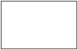
Student: ____________________________________ Level: 11th Grade ____
Total Score: ____ pts. / 34 pts. Mark:
Aims: To reinforce contents from last year.
To recognize the past form of verb to be, its use and grammar rules.

SIMPLE PAST with VERB TO BE (WAS - WERE)
I. Circle the correct form of verb to be: “was” and “were” _____/07 pts.

1) Was / Were you a good student last year?
2) Picasso was / were a great artist.
3) Were / Was English and Math your favorite subjects last year?
4) John and Teresa were / was on holiday in France.
5) We was / were at school last Saturday.
6) She was happy because it was / were her birthday.
7) Coco and Felix was / were my cats, they died 5 years ago.

II. Complete the dialogue with the correct form of verb to be: _____/09 pts.

“was”, “wasn’t”, “were” and “weren’t”.

Patrick: _______ you at the cinema with Paul yesterday?
Janice: Yes, I _______.
Patrick: _______ it a good movie?
Janice: The special effects _______ excellent, but the story _______ very good.
Patrick: Who _______ in it?
Janice: Keanu Reeves.
Patrick: _______ he good?
Janice: No, he _________, but the other actors _________ incredible.

III. Read about “Pablo Neruda” and answer the questions. _____/07 pts.
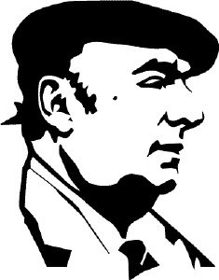
Pablo Neruda was born in the town of Parral on July 12, 1904. His real name was Neftalí Ricardo Reyes Basoalto. He was a Chilean poet and politician who became famous for his explicit love poems at an early age. He won the Nobel Prize for Literature, one of the highlights of his career. Throughout his life, Neruda was a talented and passionate man. He was one of the most important Latin American poet of the 20th century. He died of cancer on September 23, 1973.

1.- Why was Pablo Neruda famous for? He was famous…_________________________________________.
2. What was his real name? _____________________________________________________.
3.- Who was Pablo Neruda? _____________________________________________________.
4.- Where was he born? _____________________________________.
5.- When was he born? ___________________________________.
6.- What was his most important award? ______________________________________________________.
7.- What was he like? (Personality)__________________________________________________________.

IV. Look at the information and complete the texts. _____/11 pts.
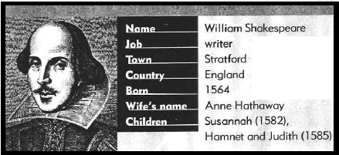

William Shakespeare was born in Stratford, England in (1) ___________. He was a famous (2) ____________.
His wife’s (3) ___________ was Anne and his children’s names (4) ___________ Susannah, Hamnet and Judith.
Susannah was (5) ___________ in 1582. Hamnet and Judith (6) ____________ born in 1585.

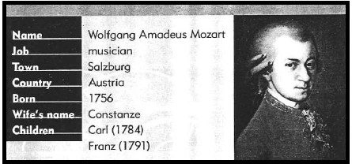

Wolfgang Amadeus Mozart was an incredible (1) ___________. He was born in (2) ____________, a town in Austria. He and his wife Constanze had two (3) ____________. Their names (4) ____________ Carl and Franz. Carl was born in 1784 and (5) ____________. in 1792.

IMPORTANT: COMPLETE THE WORKSHEET AND SEND IT TO MY E-MAIL: pablo.torres@colegioprovidencialaserena.cl

