Regular and Irregular Verbs

Name: Level: 7th ____ Date: March ___

Write the Past Tense of these verbs with the forms from the box below and
then write the meaning of each verb in Spanish.
Complete this worksheet and send it to the teacher: rosa.carcamo@colegioprovidencialaserena.cl
(20 points)

INFINITIVE | PAST TENSE | SPANISH
- Be  - Drink  - Sleep  - Work  - Like  - Write  - Go  - Make  - Play  10. Start  11. Tell  12. Travel  13. Speak  14. Have  15. Help  16. Eat  17. Study  - Live  - Send  - Read | Was - Were | Ser / Estar

Liked - Wrote - Started - Ate - Worked - Told - Was/Were
Spoke - Had - Studied - Travelled - Made - Sent - Read -
Drank - Played - Helped - Went - Lived - Slept

Cardinal Numbers
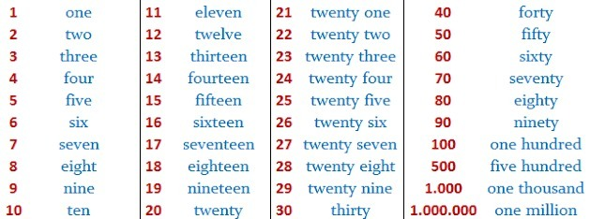
Exercise: Write down the following numbers (18 points)
532 = five hundred and thirty two.  721 =  430 =  912 =  210 =  475 = | 690 =  308 =  918 =  846 =  611 =  114 = | 377 =  401 =  819 =  202 =  613 =  520 =

