**Regular and Irregular Verbs**

Name: Level: 8th ___ Date: March ___

Match the verbs with its meaning and then match with its Past tense.

In the fouth column, identify if the verb is Regular or Irregular.

Complete this worksheet and send to the teacher: rosa.carcamo@colegioprovidencialaserena.cl

(36 points)

|  |  |  |  |
| --- | --- | --- | --- |
| **INFINITIVE** | **MEANING** | **PAST TENSE** | **REGULAR/IRREGULAR** |
| **1. Be**  **2. Drink**  **3. Sleep**  **4. Work**  **5. Like**  **6. Write**  **7. Go**  **8. Make**  **9. Play**  **10. Help**  **11. Eat**  **12. Study**  **13. Live**  **14. Send**  **15. Read**  **16. Come**  **17. Wait**  **18. Dance**  **19. Start**  **20. Tell**  **21. Travel**  **22. Speak**  **23. Finish**  **24. Answer**  **25. Have** | **___hacer**  **___ir**  **___jugar**  **___decir**  **___terminar**  **___beber**  **___enviar**  **___vivir**  **___ayudar**  **___bailar**  **___leer**  **___trabajar**  **___tener**  **___venir**  **___comer**  **___responder**  **___empezar**  **___gustar**  **___escribir**  **_1__ser/estar**  **___dormir**  **___estudiar**  **___esperar**  **___hablar**  **___viajar** | **___Waited**  **___Liked**  **___Wrote**  **___Started**  **___Ate**  **___Worked**  **___Spoke**  **___Had**  **___Studied**  **___Travelled**  **___Answered**  **___Made**  **___Came**  **___Danced**  **___Finished**  **___Read**  **___Sent**  **___Told**  **___Drank**  **___Played**  **___Helped**  **___Went**  **___Lived**  **___Slept**  **_1__Was/Were** | **1. IRREGULAR**  **2.**  **3.**  **4.**  **5.**  **6.**  **7.**  **8.**  **9.**  **10.**  **11.**  **12.**  **13.**  **14.**  **15.**  **16.**  **17.**  **18.**  **19.**  **20.**  **21.**  **22.**  **23.**  **24.**  **25.** |

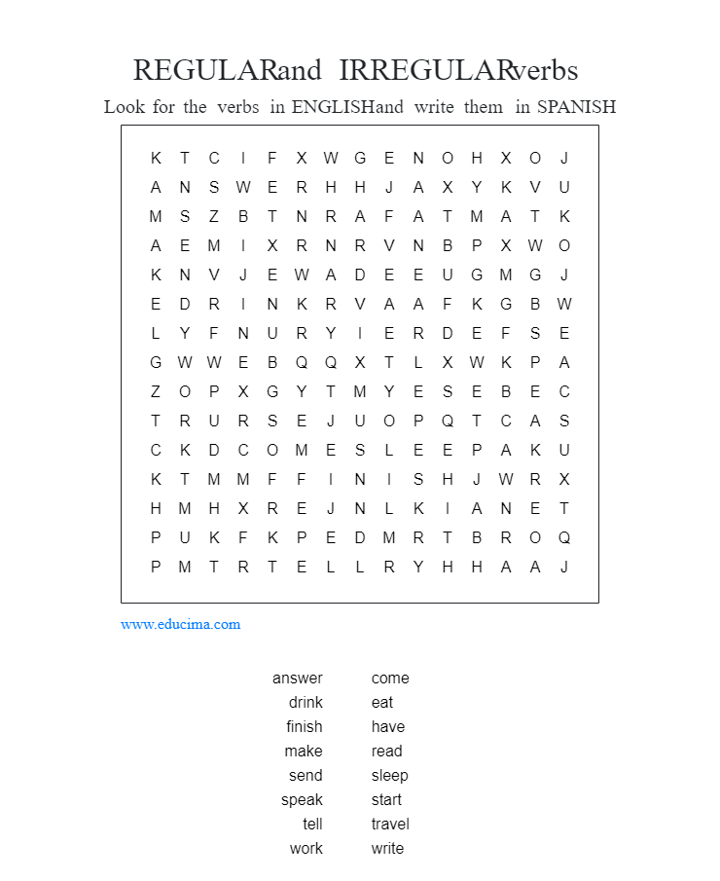

(16 points)